Pattern 3: Factory Method Pattern

**Location of the pattern:**

biz.ganttproject.core/src/main/java/biz/ganttproject/core/time/CalendarFactory.java

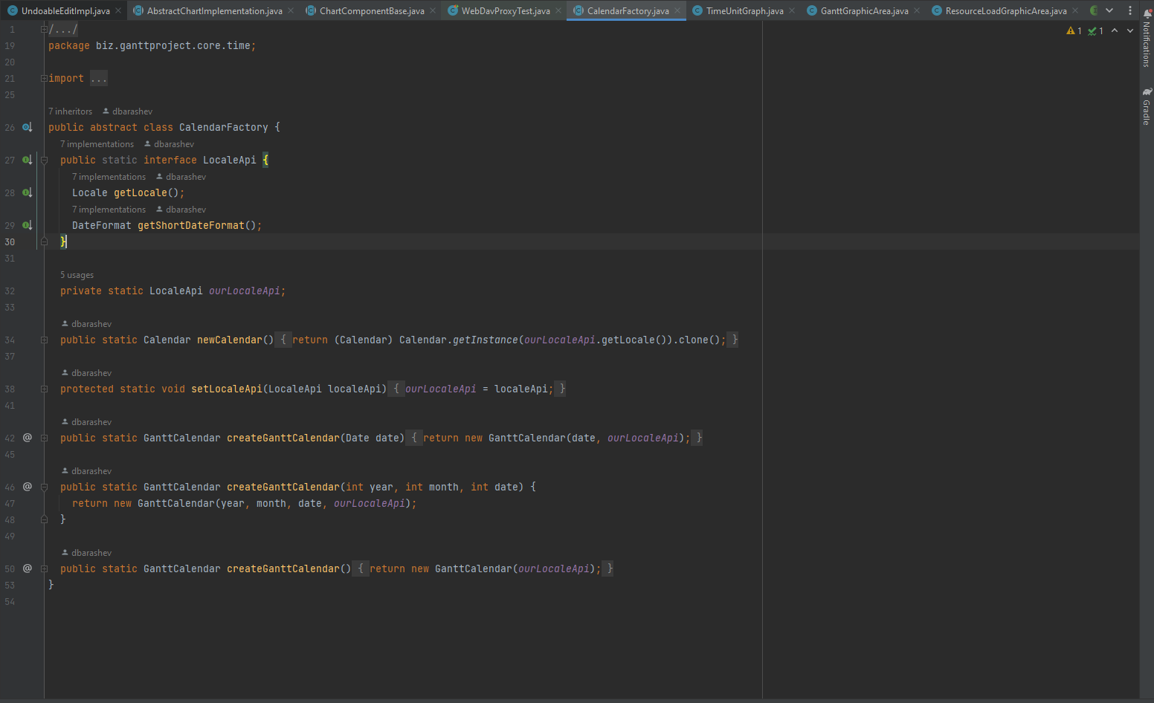

**Explanation:**

In the Factory pattern, we create objects without exposing the creation logic to the client and refer to newly created objects using a common interface.

This is exactly what the CalendarFactory class does. It creates calendar objects without exposing its creation logic to the user.

